

**NEAR, TATA NANO PLANT, SANAND, AHMDEDABAD**

ELECTRICAL | 6TH | March 10, 2018

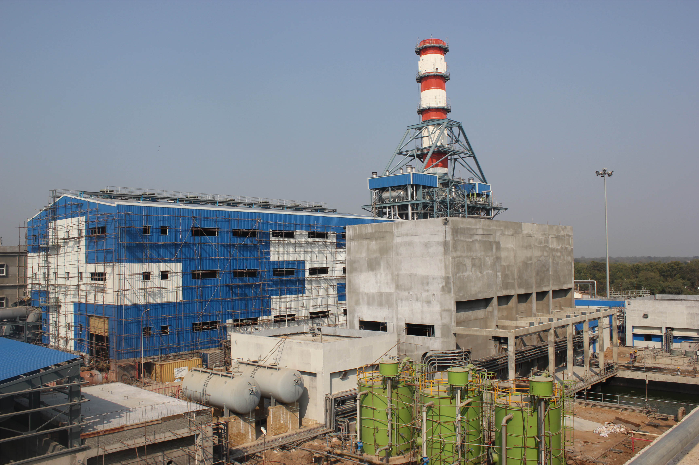

[INDUSTRIAL VISIT REPORT]

GAS BASED POR PLANT (DHUVARN)

REPORT BY:

MAKWANA MAYUR R. (161083109004)

MAKWANA NAYNEESH I. (161083109005)

PRAJAPATI MEHUL R. (161083109008)

**GAS BASED CCPP(DHUVARAN)**

**ANAND, GUJARAT.**



* **COMPANY PROFILE**

Gujarat State Electricity Corporation Limited (GSECL) was incorporated in August 1993 and is registered under the Companies Act, 1956 with the objectives to initiate a process of restructuring of Power Sector and to mobilize resources from the market for adding to the generating capacity of the State and improving the quality and cost of existing generation. The Company was promoted by erstwhile Gujarat Electricity Board (GEB) as its wholly owned subsidiary in the context of liberalization and as a part of efforts towards restructuring of the Power Sector. The Memorandum and Articles of Association of GSECL envisage a wide spectrum of activities to improve the electricity infrastructure of Gujarat. GSECL has initiated its activities in the field of Generation of Power.

The Government of Gujarat (GoG) has also given to the GSECL the status of Independent Power Producer (IPP) with approval to undertake new power projects. The Company commenced it’s commercial operation in the year 1998. However, the operations of GSECL were limited to Power Stations units Gandhinagar #5, Wanakbori #7, Utran GBPS & Dhuvaran CCPP till the complete unbundling of erstwhile GEB was undertaken, i.e. up to 31st March 2005.

As a part of the reform process, the Government of Gujarat has unbundled the various functions of GEB. As a result of this unbundling, Gujarat State Electricity Corporation Limited (GSECL) has taken up the responsibility of electricity generation. Electricity Transmission has been entrusted to the already existing company - GETCO. Distribution network in the state has been split up among four distribution companies, which cater to the northern, central, southern, and western parts of the state respectively. All these companies have been structured as subsidiaries of a holding company, Gujarat Urja Vikas Nigam Limited (GUVNL). GUVNL is also the single bulk buyer in the state as well as the bulk supplier to distribution companies. It will also carry out the trading function in the state.

**The Dhuvaran Thermal Power Station the first Power Station of** erstwhile GEB. It is located **near Khambhat in Anand District. It is Oil and Gas Based Power Station. There are four units of** 63.5 MW each (Unit no. 1 to 4), two units of 140 MW each. (Unit no. 5 & 6) with a totalinstalled capacity of 534 MW. All the above units are of General Electric, USA make. Commissioning dates of unit no. 1 to 6 are 12.07.1965, 29.04.1965, 17.02.1965, 17.12.1964, 27.05.1972 and 10.09.1972 respectively. Unit no. 1 to 4 are retired from service and unit no. 5 & 6 were derated to 110 MW w. e. f. 20.04.2007 and retired from service w.e.f. 01.12.2010.

* **DHUVARAN THERMAL POWER STATION**

The Dhuvaran thermal power station is the 1st power station of erstwhile GEB. It is located near khambhat in Anand District. It is oil and gas based power station. There are 4 units of 63.5 MW each with a total installed capacity of 534MW All the above units are of general electric, USA make. Commissioning dates unit no. 1 to 6 are 12.07.1965, 29.04.1065, 17.12.1964, 27.05,1972 & 10.09.1972 respectively. Unit 1 to 4 are retired from service and unit 5 & 6 were derated to 110MW w.e.f. 20.4.2007. and retired in 1.12.2010.

* **DHUVARAN GAS BASED CCPP- 1**

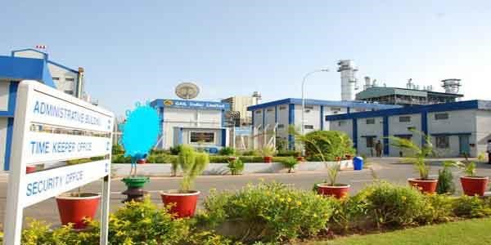

There is one gas turbine of 67.850 MW of GE make supplied by BHEL and one unit of 38.767 MW STG with total installed capacity of 106.617 MW. All above units are of GE-BHEL make. Commissioning date of unit is 28.01.2004. The unit is taken under commercial operation from 1.11.2007.

* **DHUVARAN GAS BASED CCPP- 2**

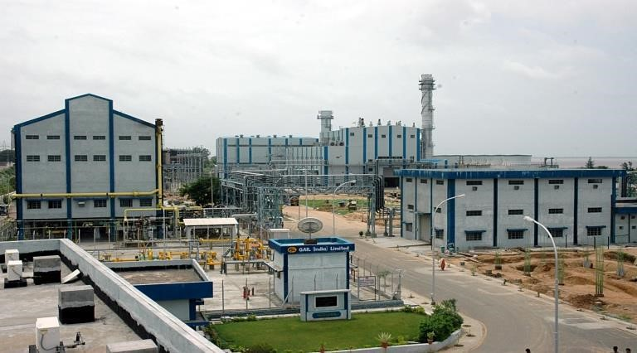

There is one gas turbine of 72.51 MW of GE make supplied by BHEL and one unit of 39.94 MW Stg with total installed capacity of 112.45 MW. All the above units are of GE- BHEL make. Gas turbine (GT) was synchronized on 17.3.2006. for 1st time in open cycle and STG was commissioned on 13.3.2007. until taken under commercial operation from 1.11.2007.

* **CAPACITY**

|  |  |  |  |  |
| --- | --- | --- | --- | --- |
|  |  |  |  |  |
| STAGE | UNIT NUMBER | INSTALLED CAPACITY(MW) | DATE OF COMMISSIONING | GT/ST |
| 1 | 1 | 67.85 | 2004 January | GT(1) |
| 1 | 2 | 38.767 | 2007 November | ST |
| 2 | 3 | 72.51 | 2006 March | GT(1) |
| 2 | 4 | 39.94 | 2007 August | ST |
| **TOTAL** | **4** | **219** |  |  |

|  |  |  |  |  |
| --- | --- | --- | --- | --- |
|  |  |  |  |  |
| YEAR | CCPP-1 | | CCP-2 | |
| GEN(MUs) | PLF(%) | GEN(MUs) | PLF(%) |
| 2004-05 | 701 | 75.05 | - | - |
| 2005-06 | 732 | 78.45 | - | - |
| 2006-07 | 262 | 28.08 | - | - |
| 2007-08 | 706 | 75.47 | 408 | 76.32 |
| 2008-09 | 523 | 55.95 | 663 | 67.30 |
| 2009-10 | 580 | 62.09 | 778 | 78.99 |
| 2010-11 | 263 | 28.25 | 627 | 63.70 |
| 2011-12 | 554 | 59.19 | 454 | 46.00 |
| 2012-13 | 850 | 44.28 |  |  |

* **PER YEAR GRGARATION:**

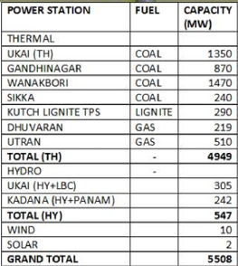

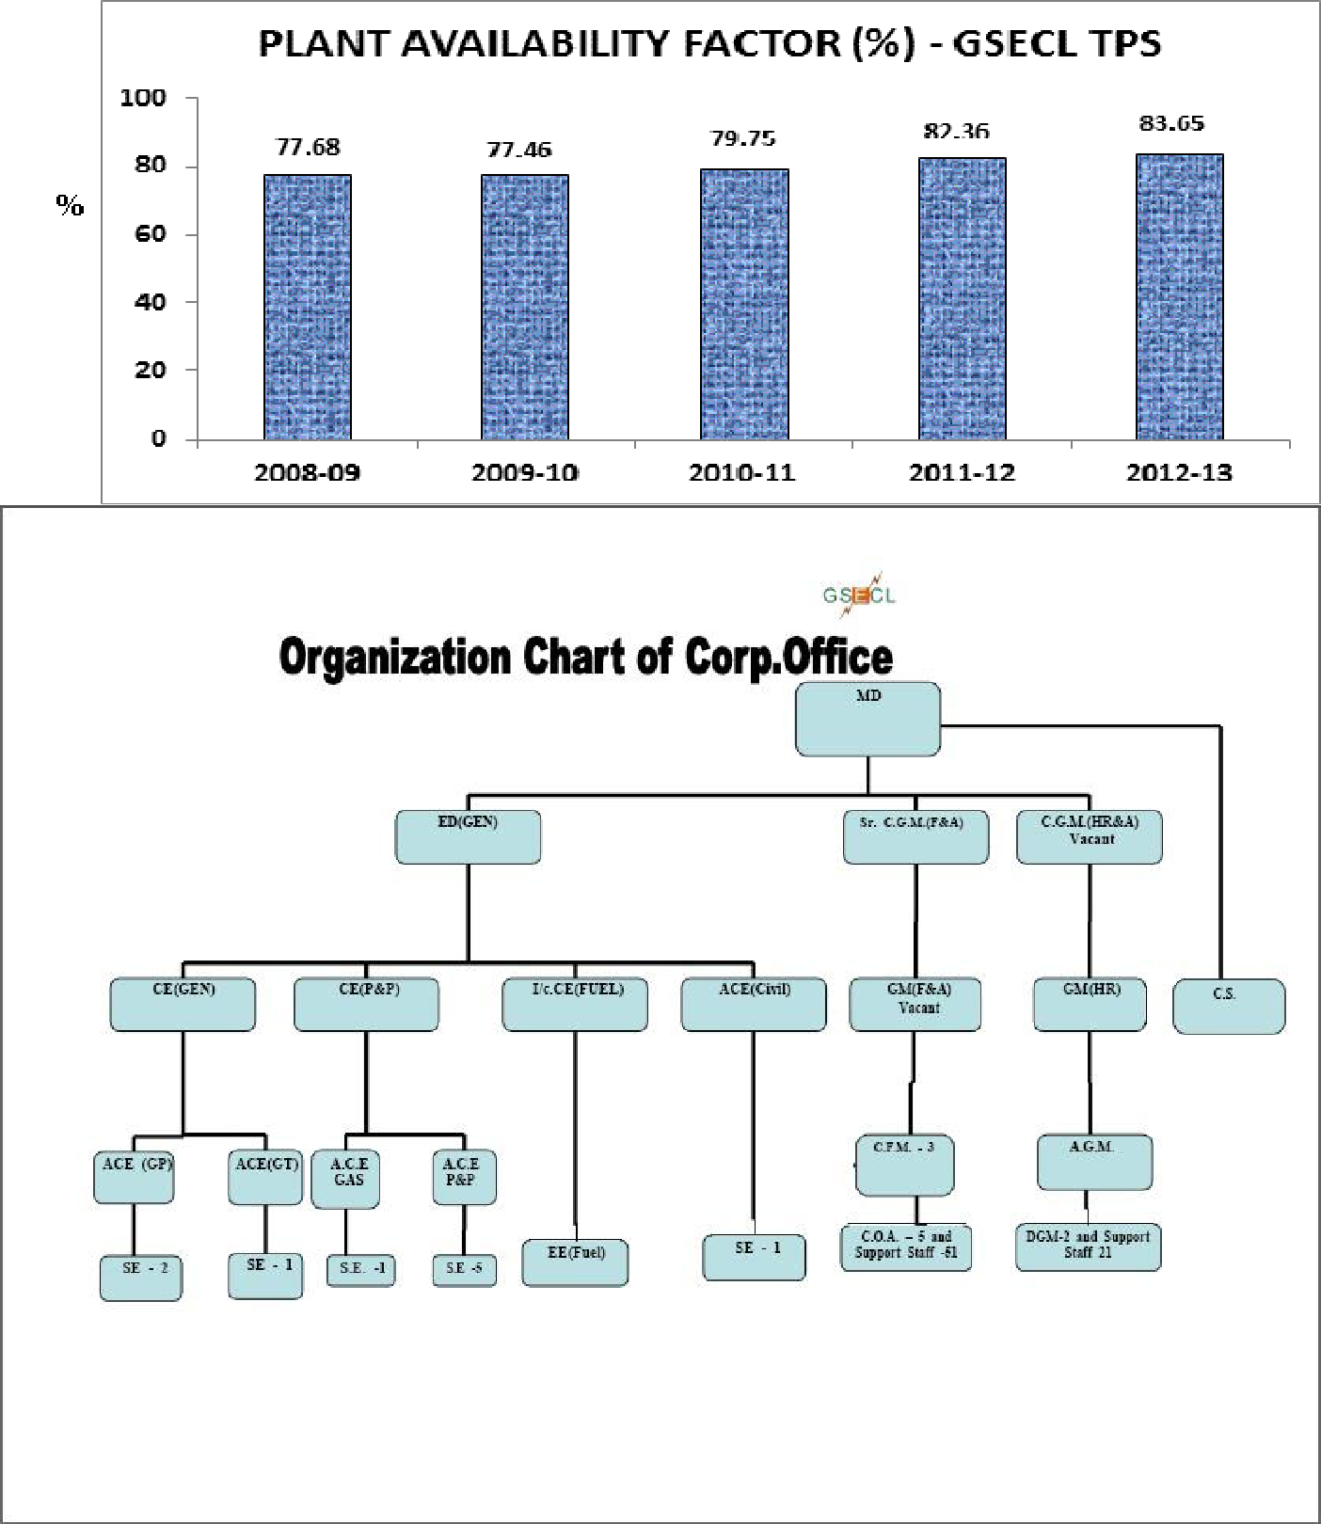

* **GAS OPRATED POWER PLANT**

Dhuvaran power plan is first gas operate power plant in Gujrat. It is part of Gujrat state electricity corporation ltd.(GSECL). It is located at dhuvaran village, taluka-khambhat, di-anand-388610. There was to units CCPP-1 and CCPP-2. It is the chipest power plant in all Gujrat power plant at no. 8.

Dhuvaran power are purchase gases from Adani or Gujrat gas. The generators are purchase from Bhell which are low speed generators. There are three types of boilers are used in power plant: -

1. High pressure
2. Intermediate pressure
3. Low pressure

The gauge is of 650v, 15.75, and 20 KV according to MW required from power plant. There are two types of generator used: -

1. Two pole generator
2. Four pole generator

The hydro generator have 24 poles. there are three types of turbine: -

1. Gas turbine
2. Steam turbine
3. Wind turbine

The output capacity of steam turbine is 80MW and output of gas turbine 46 MW. There isworldwide technology used to synchro. D.C. voltage/ field voltage/ breaker of excitation. Feed voltage is 1000-watt DC and 50 MW, 280 AMP DC excitation. MWT terminal voltage is 11KW voltage and DC excitation generator is output 0-11 KW.

Current comes after synchro. Technology to synchro. Frequency match with EW to L.EW. there is dual voltage meter: -

1. Grid meter
2. Generator voltage

For synchro both remain same can it generator will changed by varying in excitation. Voltage output 50 HZ frequency at speed 3000 rpm. 48.85 HZ Mach in grid frequency in 2015.now current speed is 50 Hz match both seed of generator.To increase speed of turbine gas combustion increases. To decrease gas combustion speed is decrease.

If phase change than synchro scope will become 90 degrees. Then it C.W increases by green height don’t use reverse synchronization. It will blast generator. 50.00grid frequency up/down national grid frequency same in all Indian power plant.

The hole Indian power plant synchronous at 31st Dec. 2013. To change it we have to shut down hole plant. Power can draw from any ware in India due to hole Indian power plant are synchronous with same thing.

1 unit Rs. 1.60variable cost. Fixed cost depend on company overall cost.13% profit is cover from government. Initial cost of hole power plant is 1800 Cr. Developed power is send to Vimal power plant Gandhinagar. 1unit =1 kW/hr. owner of power plant is government of Gujrat.

Efficiency of gas turbine is 45-50% and efficiency of steam is 98%. working of power plant is 24*7*365 days. Compressor efficiency is 85%. Output voltage of gas turbine is 24.3 MW and steam turbine is 51.7 MW. Maximum efficiency depends axial flow.

High pressure drum level is 469.4, pressure is 105.8 bar and Intermediate pressure drum 499.8, pressure 25.00 bar and low pressure drum level is 499.9, pressure 5.7.bar.

There are 2 types of deaerator for external use and internal use. Deaerator is a store a water from condenser to fuel pump to heater to distilled water. The temp. of steam will spraying C . long steam drums to maintain 10 P.H. after 2 hours checking of sample is done. Control P.H. room 7.3 distilled water production as raw water to store in reservoir. Send to R.o plant there are two types of R.o plant A and R.o plant B. mix bag R.o water outlet at degasser. The conductivity mbe-0.6 to cst-0.7 strange.

In a R.o plant 2 types of filter used: -

1. multigrade filter
2. cartage filter

the multigrade filter conductivity 1200/1500 conductivity and cartage filter conductivity 100/200 and degasser 50/70 conductivity and menoran 20 conductivity.dm water storage capacity 500 litter. 10 lakh litter water storage capacity 2 tank DM water.

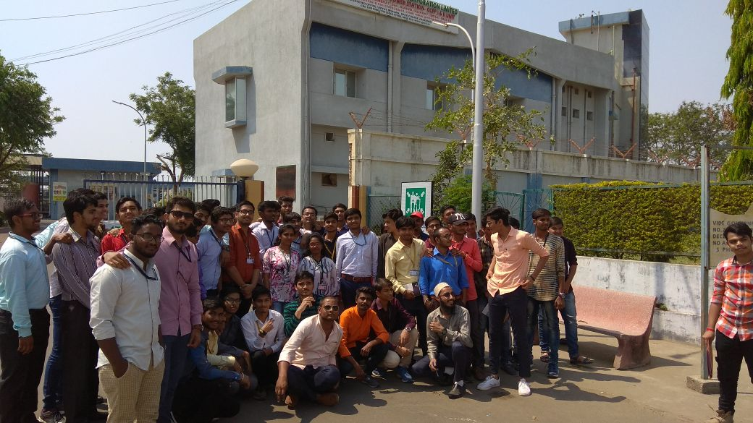

**Made by: -**

**ELECTRICAL 6th semester**

**161083109004 –Makwana Mayur R.**

**161083109005 – Makwana Naynesh I.**

**161083109008 – Prajapati mehul R.**